**Teacher Professional Development: Enhancing Classroom Instruction and Student Achievement**

**Aarti Sharma**

[**SharmaA345@gmail.com**](mailto:SharmaA345@gmail.com)

**Abstract**Teacher professional development plays a pivotal role in improving classroom instruction and ultimately enhancing student achievement. It serves as a cornerstone for educators to continually refine their teaching skills, adapt to evolving pedagogical approaches, and stay updated with the latest educational research and practices. Through targeted and well-designed professional development programs, teachers are empowered to address the diverse learning needs of their students more effectively. They gain a deeper understanding of instructional strategies, classroom management techniques, and assessment methods that are proven to boost student engagement and learning outcomes. teacher professional development fosters a culture of collaboration and reflective practice within schools. Educators have the opportunity to share insights, exchange ideas, and draw inspiration from their peers, all of which contribute to a more enriched educational environment. the ripple effect of effective professional development extends to the students themselves. When teachers are equipped with the knowledge and tools to excel in their roles, students benefit from more engaging and impactful instruction.

**Keywords:** Teacher Professional Development, Classroom Instruction, Student Achievement, Educational Improvement, Pedagogical Approaches

**Introduction**

Teacher professional development is an indispensable component of modern education, serving as a catalyst for the enhancement of classroom instruction and the ultimate improvement of student achievement. In today's dynamic educational landscape, the role of educators extends far beyond imparting knowledge; they must continually adapt to evolving pedagogical methods, incorporate innovative strategies, and meet the diverse learning needs of their students. This necessitates a commitment to ongoing learning and growth, and professional development offers precisely that. It equips teachers with the knowledge, tools, and skills needed to excel in their roles, enabling them to create vibrant and effective learning environments. As teachers refine their instructional techniques, explore new assessment methods, and embrace collaborative practices, their classrooms become hubs of engaged and empowered learners. In this context, we delve deeper into the significance of teacher professional development and its profound impact on classroom dynamics and student success. In the realm of education, the pivotal role of teacher professional development cannot be overstated. It stands as the cornerstone upon which effective classroom instruction and, subsequently, student achievement are built. In today's fast-paced and ever-evolving educational landscape, teachers face the formidable task of not only disseminating knowledge but also fostering critical thinking, problem-solving skills, and a love for learning in their students. To meet these demands, teachers must be perpetual learners themselves, open to adopting new teaching strategies, leveraging the latest educational technologies, and accommodating the diverse needs of their students. This is where teacher professional development enters the picture. It serves as the lifeblood of educational progress, offering teachers opportunities to refine their instructional approaches, delve into research-driven best practices, and collaborate with peers to enhance their pedagogical prowess. In essence, it empowers educators to create vibrant and transformative learning experiences for their students. This introduction sets the stage for a deeper exploration of the multifaceted impacts of teacher professional development, demonstrating how it not only elevates classroom instruction but also sets the course for heightened student achievement and a brighter educational future.

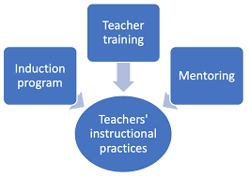

**Pedagogical Innovations:**

Pedagogical innovations are the lifeblood of education's evolution, continually reshaping how knowledge is imparted and acquired. In the fast-paced digital age, where information flows at unprecedented rates, educators find themselves at the intersection of tradition and transformation. The traditional role of teachers as knowledge providers has expanded to that of facilitators, mentors, and guides in a dynamic learning landscape. Pedagogical innovations, powered by teacher professional development, are the driving force behind this transformation. They encompass a wide array of creative teaching strategies, methodologies, and technologies designed to engage students, enhance comprehension, and foster critical thinking. From flipped classrooms and gamification to project-based learning and personalized education pathways, these innovations represent a commitment to adapt and thrive in an ever-evolving educational ecosystem. In this exploration of pedagogical innovations, we delve into how teacher professional development not only introduces these groundbreaking approaches but also empowers educators to integrate them effectively into their classrooms, paving the way for enriched instructional experiences and heightened student achievement.

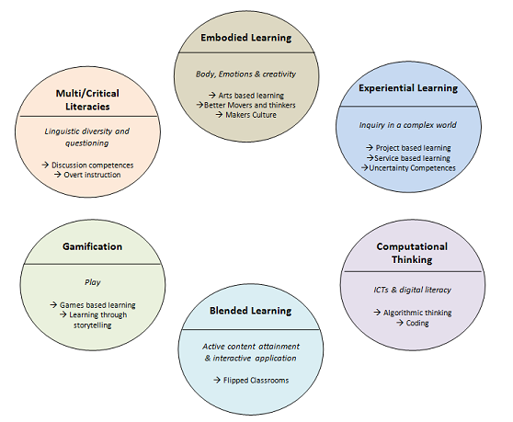

**Assessment and Data-Driven Decision-Making**

In the pursuit of educational excellence, one of the most transformative aspects of contemporary teaching is the shift towards data-driven decision-making. In a world that generates an unprecedented volume of information, educators have recognized the immense value of harnessing data to inform their instructional choices and enhance student outcomes. This shift is not merely an abstract concept but a tangible transformation, driven by teacher professional development. Assessment and data-driven decision-making have become linchpins in the educational process, allowing teachers to move beyond traditional assessment methods and instead leverage a rich tapestry of student data to personalize learning experiences. Through professional development, educators gain the skills to design and implement assessments that provide meaningful insights into student progress, strengths, and areas for improvement. They learn to decipher data, identify patterns, and adjust their teaching strategies accordingly, creating a dynamic and responsive learning environment. In this exploration of assessment and data-driven decision-making, we uncover how teacher professional development equips educators with the tools to harness the power of data, thereby elevating instructional quality and propelling students towards greater academic achievement.

**Conclusion**

In the grand tapestry of education, the thread of teacher professional development weaves a compelling narrative of growth, transformation, and enduring impact. As we reach the culmination of ouar exploration into its role in enhancing classroom instruction and student achievement, it becomes abundantly clear that professional development is not a mere professional obligation; it is the cornerstone upon which educational excellence is built. Through this journey, we have witnessed the evolution of teaching from a static, one-size-fits-all approach to a dynamic, student-centered experience. Teacher professional development has been the catalyst, enabling educators to harness pedagogical innovations, leverage data, and collaborate within rich learning communities. It has equipped them with the skills to engage diverse student populations, adapt to changing paradigms, and lead the charge in transforming traditional classrooms into vibrant centers of discovery., professional development has transcended its immediate impact on teachers. Its true resonance reverberates through the corridors of student achievement. When educators are empowered to excel, their students are the beneficiaries. We've seen how enhanced classroom instruction, driven by professional development, fosters deeper comprehension, heightened motivation, and a thirst for knowledge among learners. The symbiotic relationship between teacher professional development, classroom instruction, and student achievement is a testament to the enduring potential of education. It is a continuous journey where teachers become lifelong learners, and students become lifelong achievers. As we embrace the future, it is imperative that we continue to invest in high-quality professional development opportunities, for in doing so, we invest in the limitless potential of generations to come. It is a commitment not only to the present but also to the ever-evolving promise of education itself.

**References**

1. Darling-Hammond, L., Wei, R. C., Andree, A., Richardson, N., & Orphanos, S. (2009). Professional learning in the learning profession: A status report on teacher development in the United States and abroad. Stanford, CA: National Staff Development Council.
2. Inan, F. A., & Lowther, D. L. (2010). Factors affecting technology integration in K-12 classrooms: A path model. Educational Technology Research and Development, 58(2), 137-154.
3. Guskey, T. R. (2002). Professional development and teacher change. Teachers and Teaching, 8(3), 381-391.
4. Hattie, J. (2009). Visible learning: A synthesis of over 800 meta-analyses relating to achievement. New York, NY: Routledge.
5. Marzano, R. J., Frontier, T., & Livingston, D. (2011). Effective supervision: Supporting the art and science of teaching. Alexandria, VA: ASCD.
6. Darling-Hammond, L., & McLaughlin, M. W. (1995). Policies that support professional development in an era of reform. Phi Delta Kappan, 76(8), 597-604.
7. Ingersoll, R. M., & Strong, M. (2011). The impact of induction and mentoring programs for beginning teachers: A critical review of the research. Review of Educational Research, 81(2), 201-233.
8. Guskey, T. R., & Yoon, K. S. (2009). What works in professional development? Phi Delta Kappan, 90(7), 495-500.